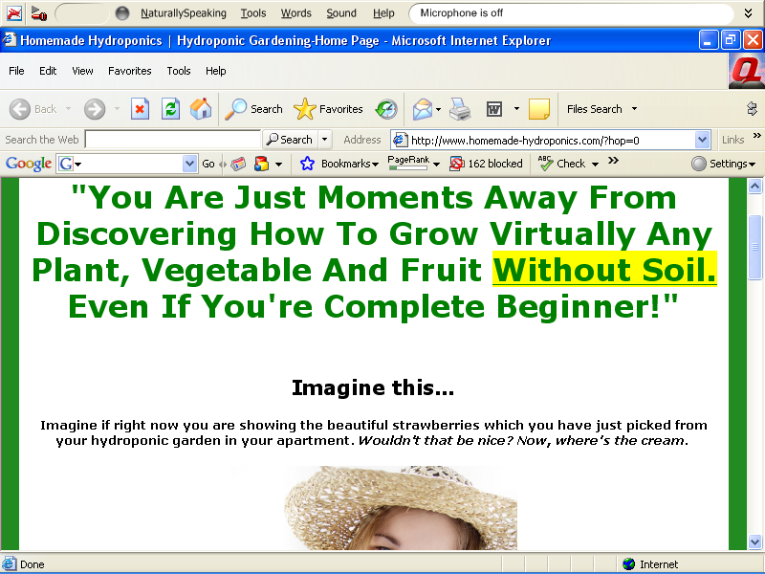
Hydroponic Gardening. With Hydroponic Gardening You Can Grow Anything Indoors Or Outdoors Without Using Soil And With Amazing Results!
$/sale: $18.80 | Future $: - | Total $/sale: $18.80 | %/sale: 75.0% | %refd: 83.0% | grav: 3.99
view pitch page | create hoplink

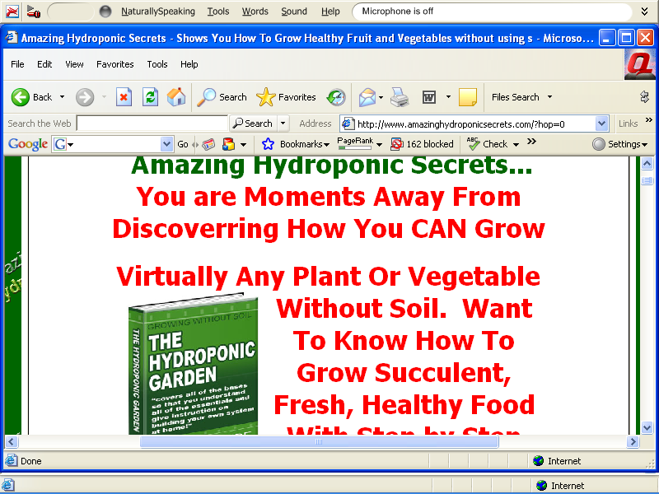
The Hydroponic Garden Secrets Guide. Hydroponics Secrets Shows You How To Grow The Plants, Fruits And Vegetables -even In Limited Space--without Using Soil. An Amazi.
$/sale: $19.64 | Future $: - | Total $/sale: $19.64 | %/sale: 60.0% | %refd: 47.0% | grav: 0.14
view pitch page | create hoplink

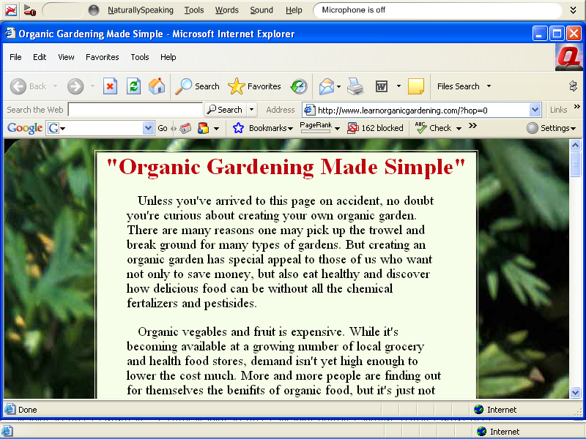

Organic Gardening How-To. Create Your Own Organic Garden! As The Organic Movement Grows, Be At The Forefront Helping Homeowners Get Started. Easy To Understand And Use - Make Money Helping People With This EBook!
$/sale: $7.31 | Future $: - | Total $/sale: $7.31 | %/sale: 70.0% | %refd: 100.0% | grav: 1.44
view pitch page | create hoplink

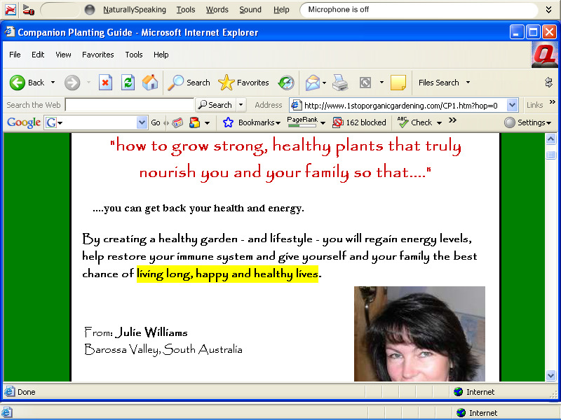
Companion Planting. Learn How To Design An Organic Food System Where Your Plants Do The Work, Creating A High Yield, Healthy, Beautiful Garden.
$/sale: - | Future $: - | Total $/sale: - | %/sale: - | %refd: - | grav: -
view pitch page | create hoplink

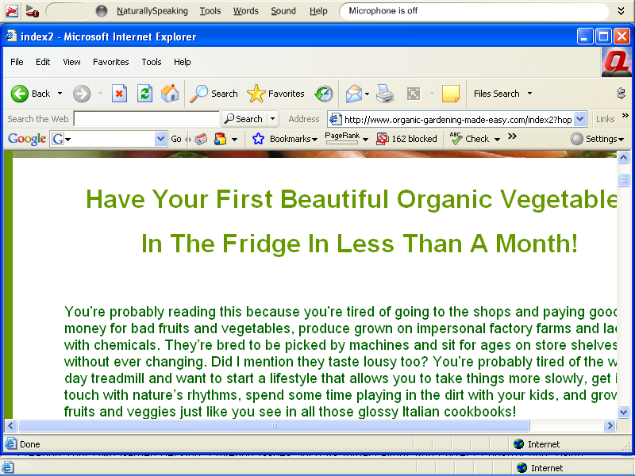
Organic Gardening Made Easy. A Revolutionary, Tip-packed Book For The Novice And Experienced Gardener Alike. Learn How To Grow Your Own Organic Fruits And Veggies And Have Some Of Them On The Table In Less Than A Month!
$/sale: - | Future $: - | Total $/sale: - | %/sale: - | %refd: - | grav: -
view pitch page | create hoplink

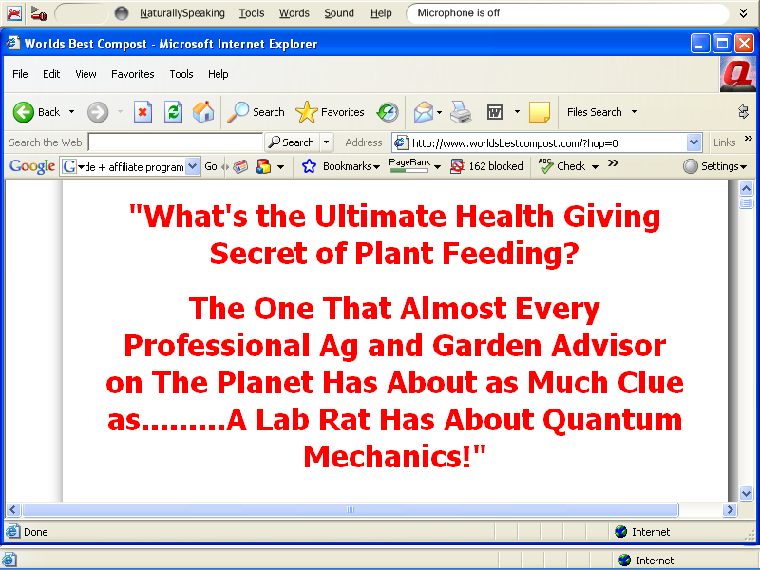

World's Best Compost. Make The World's Ultimate Natural Fertilizer, Colloidal Humus, Without Bins, Turning Or Odor.
$/sale: $14.99 | Future $: - | Total $/sale: $14.99 | %/sale: 50.0% | %refd: 22.0% | grav: 4.47
view pitch page | create hoplink (Word of caution, dude has a video sales letter, and starts blabbing away. I hate marketers who don’t give you the chance to hit play, but insist on blasting you with their audio, whether you want it or not. I can’t let this take away from the product.)

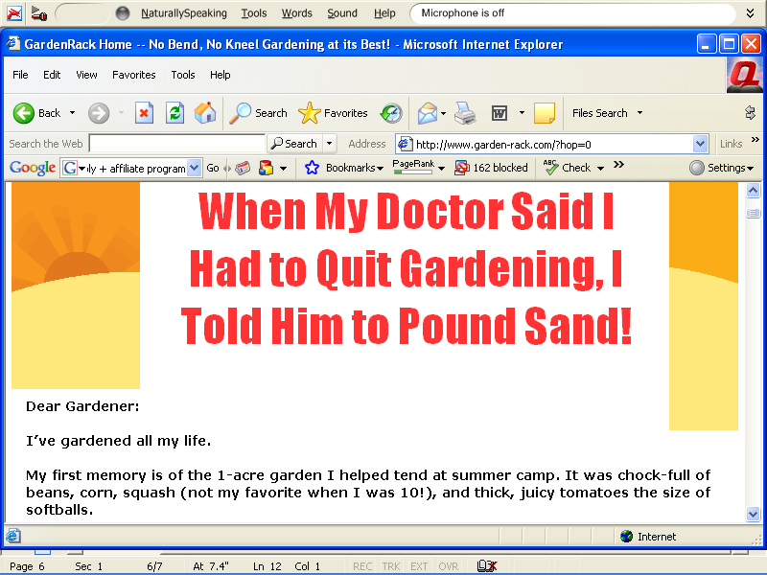
GardenRack. No Bend, No Kneel Gardening At Its Best!
$/sale: - | Future $: - | Total $/sale: - | %/sale: - | %refd: - | grav: -
view pitch page | create hoplink
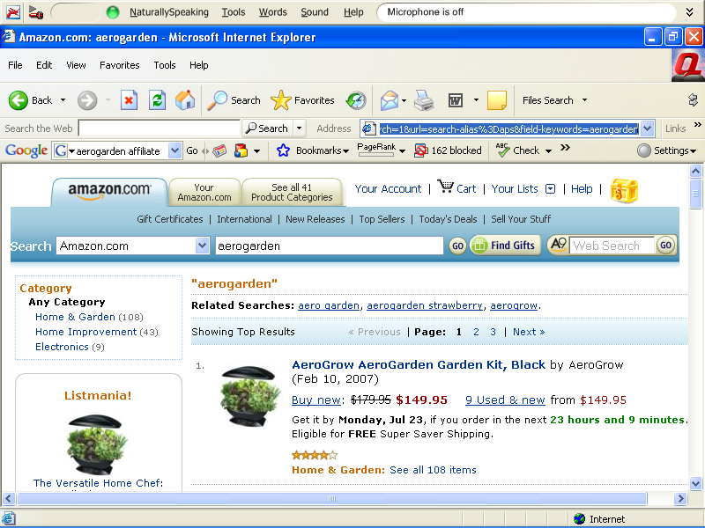
http://www.amazon.com/s/ref=nb_ss_gw/105-9217050-8069261?initialSearch=1&url=search-alias%3Daps&field-keywords=aerogarden

That’s to see the product, to sign up for amazon.com’s aff program go here:
http://affiliate-program.amazon.com/gp/associates/join

